**Getting started with Web UI part of the ConvergedConfereceApp Project in IDE**

1. **Install latest JDK (JDK 1.7 U 71 used here as an example)**
2. **Install Groovy/Grails Tool Suite IDE:** [**http://spring.io/tools/ggts**](http://spring.io/tools/ggts)
3. **Configure installed IDE to use installed JDK 1.7.**

Open Grails Suite and navigate to Window->Preferences:

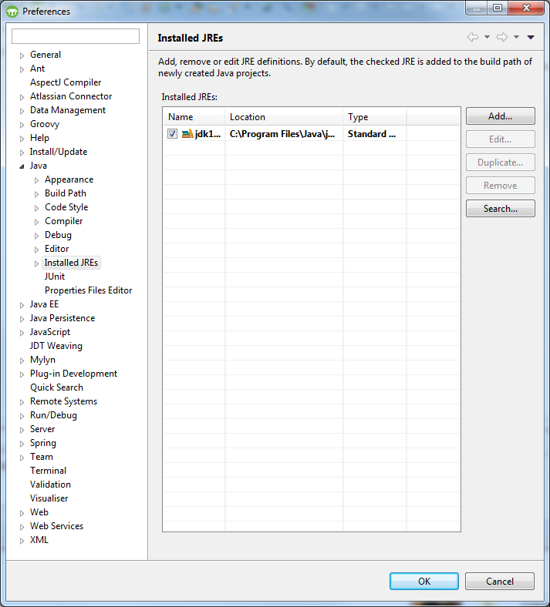

Now under “Java”->”Installed JREs” make sure that installed JDK is the one referenced as shown here:

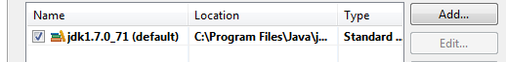

If not, click on “Add” button:

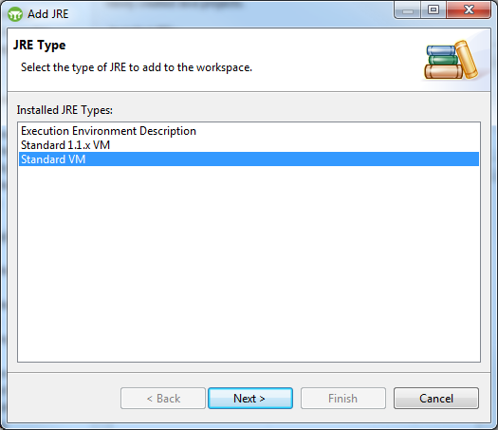

Select Standard VM and click “Next”:

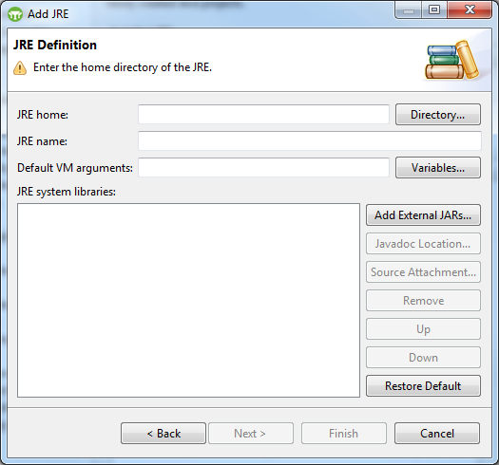

Click on “Directory” button:

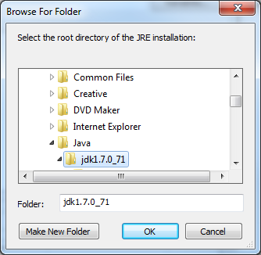

And then navigate to the appropriate JDK installed in step 1).

Click “OK”

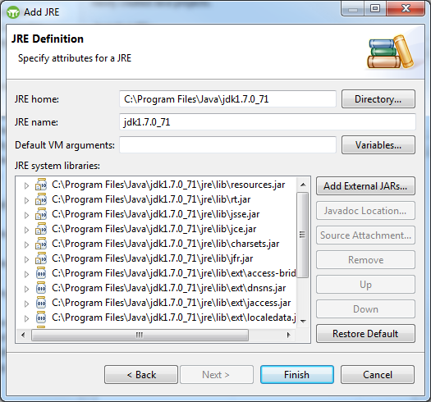

Now, click “Finish”

Now, the Preferences window will be displayed and make sure that appropriate JDK is selected under “Installed JREs” (and only one):

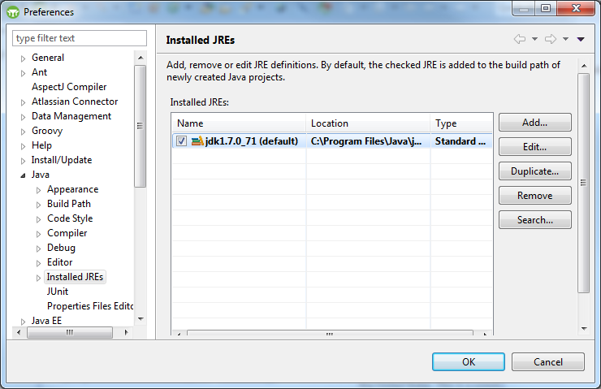

Click “OK”

1. **Unzipping the package.**

Unzip the project file and place its content in a known directory. Note, it needs to reside outside of the Grails workspace directory.

1. **Opening the project in IDE.**

Go to Grails and click File->Import:

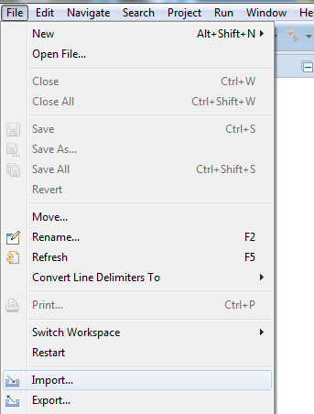

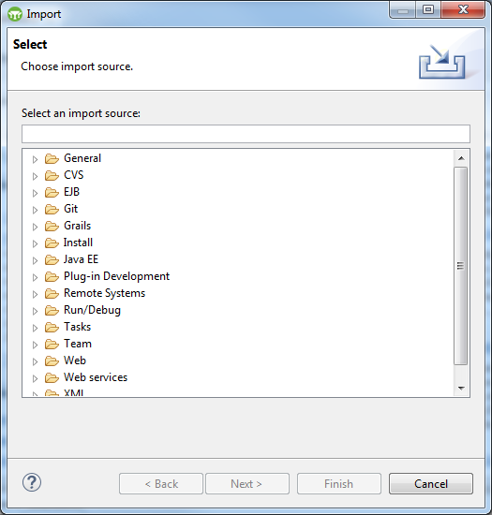

Under “Grails” select “Grails Project”:

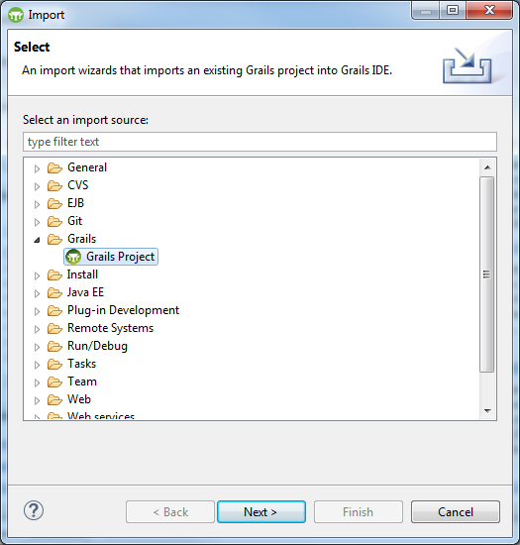

Now click “Next” button:

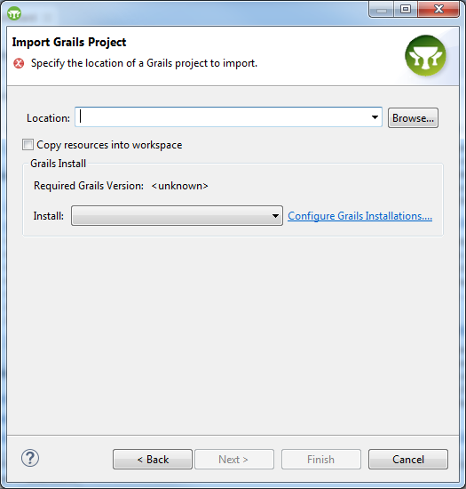

Now, click “Browse” button and select the project directory unzipped in step 4:

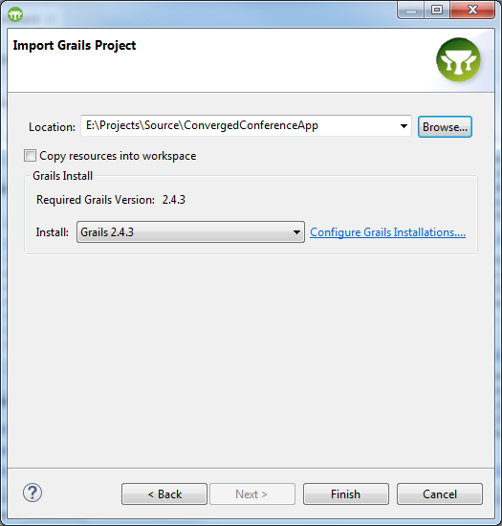

Make sure to check “Copy resources into workspace” in order for all the necessary components to be brought into the workspace directory itself:

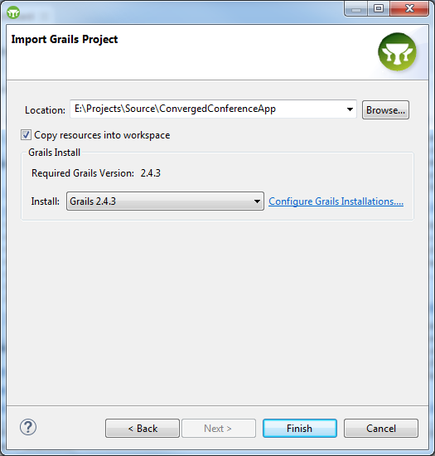

Now click “Finish” button.

In the console window of Grails you should see automatic project build taking place. Once complete the “Console” window should TERMINATED at the top of the console window:

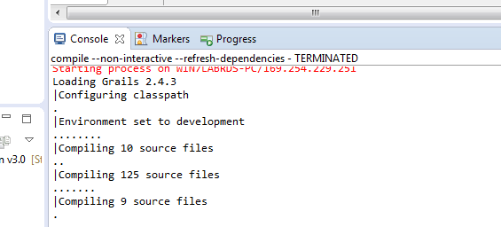

1. **Building the WAR file.**

To build a deployable J2EE “war” file first right mouse click on the project in Grails Suite:

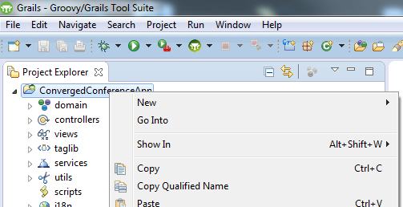

and click on “Grails Tools”->”Open Grails Command Prompt”:

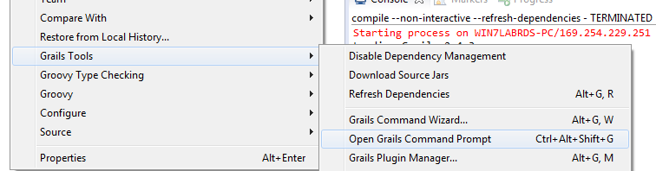

Now, the following prompt will appear:

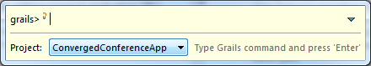

Syntax of building a “WAR” file is as follow: “dev war <ApplicationName>.war” (example: CustConvergedConferenceApp.war). Then simply hit enter to execute war building process. Once successful the “Console” window in Grails Suite will display the following:

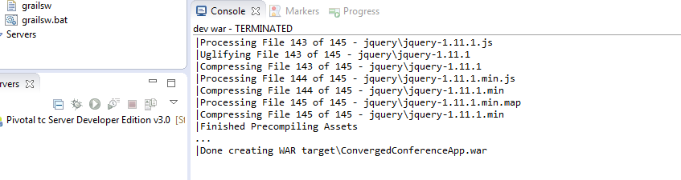

**Note: the war file will be created in the root of your project directory.**

1. **Connecting standalone project to remotely configured dlgmsc_conf.war application.**

In a standalone development setup of ConvergedConferenceApp application it still needs to be able to interact with dlgmsc_conf.war application. Since in such setup they are not located on the same system a small code modification needs to be made to point one to the other. In short, we need to change ConvergedConferenceApp to reference dlgmsc_conf.war app by its remote IP address and port. Below are the steps on how to change it:

* Under “Project Explorer” navigate to the ConvergedConferenceApp project and go to “web-app”->”js” folder:

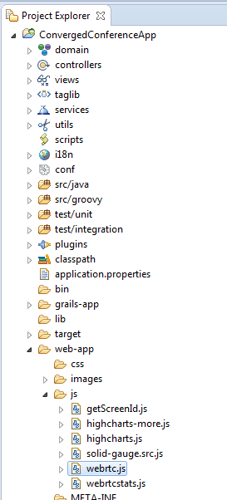

* double click on “webrtc.js” file:

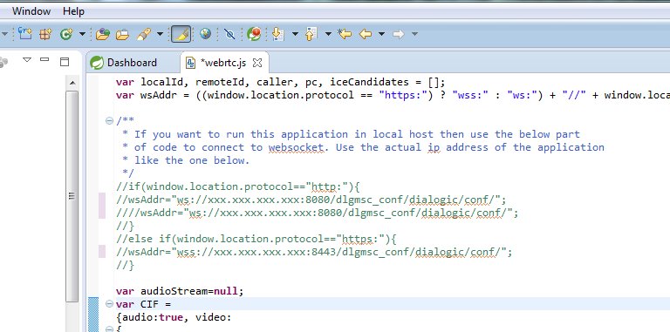

* By default, the UI application war file expects the dlgmsc_conf.war app to be running on localhost. To change that uncomment 7 lines (marked green above) and replace xxx.xxx.xxx.xxx with the TeleStax AS IP address (illustrated bellow):

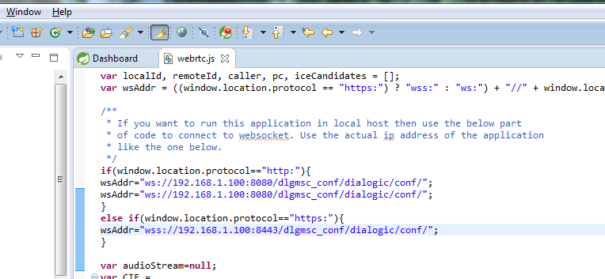

* In order for above changes to take an effect we need to re build the war file by following steps described in section 6).

1. **Running the project in local Grails Suite.**

Note, make sure that section 7) is completed.

Right mouse click on the ConvergedConferenceApp project in “Project Explorer”, click on “Run As” and select “2 Grails Command (run-app)”:

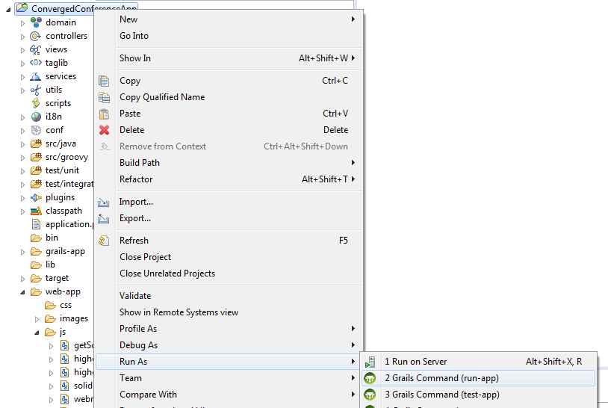

Once the above step is successful the “Console” window should display the following message with Grail Suite local URL. This URL will be used for the local browser to connect to locally running instance of ConvergedConfereceApp:

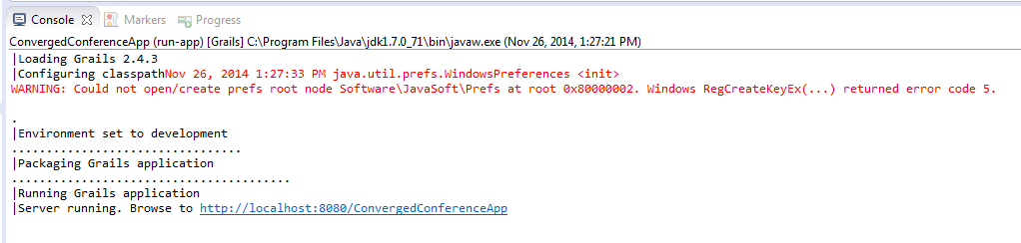

Now, copy the “Brose to” link as shown above and paste it into the Chrome browser. You should now be able to get the ConvergedConfereceApp welcome screen:

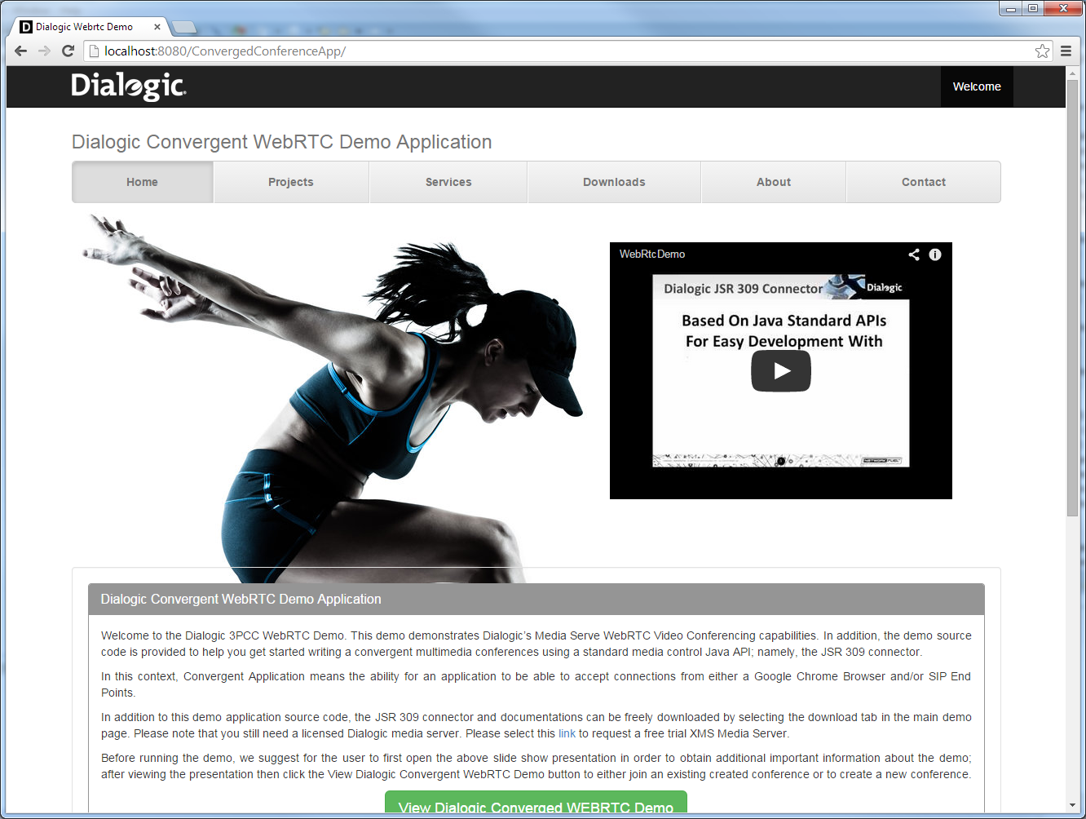

Click on “View Dialogic Converged WEBRTC Demo” link to start the demo.